Университет ИТМО

Факультет программной инженерии и компьютерной техники

Лабораторная работа №2
по «Алгоритмам и структурам данных»

Выполнил:
Студент группы P3210
Нгу Фыонг Ань

Преподаватели:
Косяков М.С.
Тараканов Д.С.

Санкт-Петербург
2019
1207 – Median on the plane
Note:
- There are N points on the plane (N is even).
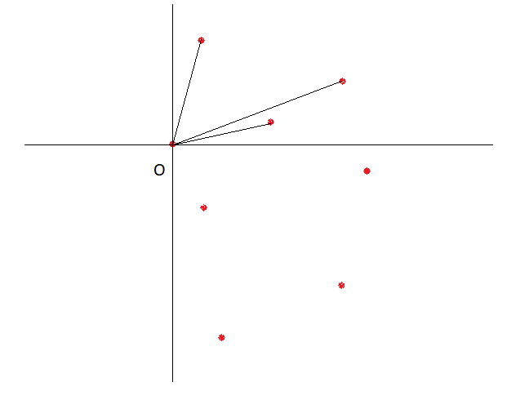
- No three points belong to the same straight line.
Algorithm:
- Pick a point that have the min(x). Let’s call it point O.
- Build a coordinate system with O is the center.
- Sort all remaining point according to their tan value. For the angle from [-pi; +pi] the tan value is from [-inf; +inf];
- O and then middle point of the sorted array should be the 2 points that divide the set of points into two equal-sized parts.

1604 – Country of fools
Note:
- There are n_{i} sign with value i.
- The driver would have to change speed as many times as possible.
- The speed is changed if 2 signs next to each other have different values.
So here is what we gonna do:
- We will make sure the 2 signs with the largest amount are always at position 1 and 2 of the array (using sorting if a3 > min(a1,a2)). Call them sign A and B.
- Put A and B next in the sequence. Decrease the amount if sign A and B.
- Return to step 1 until there is only 1 sign left / all the sign is set in the sequence.

1726 - Visits
Part 1:
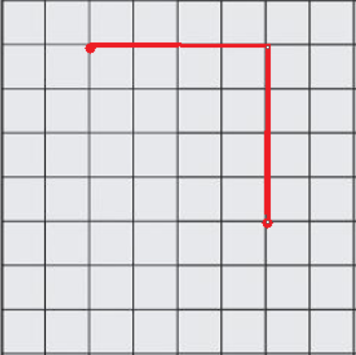
All the members of the program committee walk only along the streets, and they always choose the shortest way.
<= So they always go like this. And the path length would be del(x)+del(y).
With n paths, we can split it into sum of del(n,x) and sum of del(n,y).

Part 2: So how do we caculate the sum of del(n, x)?
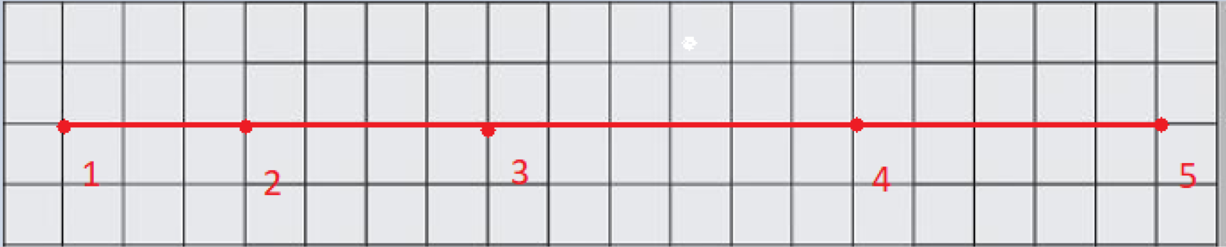
Let’s assume this is our path with x1<= x2<= … <= x5 <=… (this could be achieve by using sort).
The path from 1 -> 2 is (x2 – x1) = s1;
The path from 1,2 -> 3 is s1 + (x3-x2)*2 = s2;
The path from 1,2,3 -> 4 is s2 + (x4 – x3) *3 = s3;
The path from 1,2,3,4 -> 5 is s3 + (x5-x4) * 4 = s4;
The path from 1,2, … k -> k+1 is s_{k-1} + (x_{k+1} – x_{k})*k = s_{k}
And so on.
The sum of del(n, x) would be s1 + s2 +s3 + s4 + … s_{n-1}
This formular can also be used to calculate sum del(n, y).
The final result would be (del(n,x)+del(n,y))/(n*(n-1)/2)

